|  |  |  |  |  |  |  |  |  |  |  |  |  |  |  |  |  |  |  |  |
| --- | --- | --- | --- | --- | --- | --- | --- | --- | --- | --- | --- | --- | --- | --- | --- | --- | --- | --- | --- |
| |  |  |  |  |  |  |  |  | | --- | --- | --- | --- | --- | --- | --- | --- | | ***Paper piecing A New York Beauty Step By Step***  ***\*\* This is my method of making the blocks, sewing the curves, and paper piecing, there are many different ways, you may wish to try them all to see what works best for you \*\****    ***Patterns found below can be used with the instructions provided, the finished quilt blocks will measure 7 inches (7 1/2 unfinished)***   |  | | --- | | Top of Form  Bottom of Form |  |  |  | | --- | --- | | practice3pic.jpg | practice4pic.jpg |  * ***The first thing you need to do is cut out your templates, lay them out and fold each in half and mark the center on all sections that will be sewn together.***   [000_1111.jpg](http://quilterscornerclub.tripod.com/imagelib/sitebuilder/misc/show_image.html?linkedwidth=560&linkpath=http://www.quilterscornerclub.com/sitebuildercontent/sitebuilderpictures/.pond/000_1111.jpg.w560h754.jpg&target=tlx_new)   * ***Next, Cut a square of fabric large enough for your template C- lay the fabric face down, as shown in picture, place the paper template on top, face up, and pin to your fabric...After it is pinned well enough, trim around the template leaving some fabrc past the ¼ inch seam allowance (room for error)***  |  |  | | --- | --- | | [000_1113.jpg](http://quilterscornerclub.tripod.com/imagelib/sitebuilder/misc/show_image.html?linkedwidth=560&linkpath=http://www.quilterscornerclub.com/sitebuildercontent/sitebuilderpictures/.pond/000_1113.jpg.w560h754.jpg&target=tlx_new) | [000_1114.jpg](http://quilterscornerclub.tripod.com/imagelib/sitebuilder/misc/show_image.html?linkedwidth=560&linkpath=http://www.quilterscornerclub.com/sitebuildercontent/sitebuilderpictures/.pond/000_1114.jpg.w560h416.jpg&target=tlx_new) |  * ***Now we are going to sew this paper to our fabric, all the way around, inside the ¼ seam allowance (not on the line) This will give stability when we are sewing the sections together. Remove the pins as you come to them, also I like to use a large stitch width for this part. I’m really just basting the pattern to the fabric. When you come to the end, do not enclose the stitches, stop about ½ inch before the start point. This way if you need to loosen your stitches you can just give it a tug and it will have somewhere to go ☺***  |  |  | | --- | --- | | [000_1116.jpg](http://quilterscornerclub.tripod.com/imagelib/sitebuilder/misc/show_image.html?linkedwidth=actual&linkpath=http://www.quilterscornerclub.com/sitebuildercontent/sitebuilderpictures/000_1116.jpg&target=tlx_new) | [000_1117.jpg](http://quilterscornerclub.tripod.com/imagelib/sitebuilder/misc/show_image.html?linkedwidth=560&linkpath=http://www.quilterscornerclub.com/sitebuildercontent/sitebuilderpictures/.pond/000_1117.jpg.w560h416.jpg&target=tlx_new) |  * ***Now I have sewn all around the section, and basted my fabric on, and I am going to trim all the excess fabric that is past the seam allowance paper edge, so I have a perfect piece***   [000_1122.jpg](http://quilterscornerclub.tripod.com/imagelib/sitebuilder/misc/show_image.html?linkedwidth=560&linkpath=http://www.quilterscornerclub.com/sitebuildercontent/sitebuilderpictures/.pond/000_1122.jpg.w560h416.jpg&target=tlx_new) | | http://quilterscornerclub.tripod.com/imagelib/sitebuilder/layout/spacer.gif | | |  | | --- | |  | | http://quilterscornerclub.tripod.com/imagelib/sitebuilder/layout/spacer.gif | |  | | http://quilterscornerclub.tripod.com/imagelib/sitebuilder/layout/spacer.gif | |  | | http://quilterscornerclub.tripod.com/imagelib/sitebuilder/layout/spacer.gif | |  | | |  | | http://quilterscornerclub.tripod.com/imagelib/sitebuilder/layout/spacer.gif |
| http://quilterscornerclub.tripod.com/imagelib/sitebuilder/layout/spacer.gif | | |

* ***Now I am going to do the same thing with the unit A - pin, baste (sew) and trim…***

|  |  |
| --- | --- |
| [000_1123.jpg](http://quilterscornerclub.tripod.com/imagelib/sitebuilder/misc/show_image.html?linkedwidth=560&linkpath=http://www.quilterscornerclub.com/sitebuildercontent/sitebuilderpictures/.pond/000_1123.jpg.w560h493.jpg&target=tlx_new) | [000_1124.jpg](http://quilterscornerclub.tripod.com/imagelib/sitebuilder/misc/show_image.html?linkedwidth=560&linkpath=http://www.quilterscornerclub.com/sitebuildercontent/sitebuilderpictures/.pond/000_1124.jpg.w560h579.jpg&target=tlx_new) |

* ***Now its time for the paper piecing- This is also my method, you may paper piece differently, but you also might like to try something new I start off by measuring my number 1 piece on the paper unit-***

[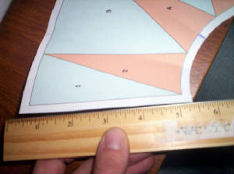](http://quilterscornerclub.tripod.com/imagelib/sitebuilder/misc/show_image.html?linkedwidth=560&linkpath=http://www.quilterscornerclub.com/sitebuildercontent/sitebuilderpictures/.pond/000_1125.jpg.w560h416.jpg&target=tlx_new)

* ***I’m going to cut a rectangle of fabric that measures 3.5 by 6 inches. This is about an inch wider, in both directions, than needed, I like to be on the safe side plus I am going to cut this in half diagonally to make two triangles …***

|  |  |
| --- | --- |
| [000_1133.jpg](http://quilterscornerclub.tripod.com/imagelib/sitebuilder/misc/show_image.html?linkedwidth=560&linkpath=http://www.quilterscornerclub.com/sitebuildercontent/sitebuilderpictures/.pond/000_1133.jpg.w560h918.jpg&target=tlx_new) | [000_1136.jpg](http://quilterscornerclub.tripod.com/imagelib/sitebuilder/misc/show_image.html?linkedwidth=560&linkpath=http://www.quilterscornerclub.com/sitebuildercontent/sitebuilderpictures/.pond/000_1136.jpg.w560h771.jpg&target=tlx_new) |

* ***Do the same for your number 2 piece, before you cut in half on the diagonal just make sure the fabric will cover the area, lay your fabric on top of the numbered section, FACE UP, and see if it covers it well enough to cut in half…***
* ***Now I take my Piece 1 fabric and lay it face down, I take my Paper unit and FOLD along the number 1 and 2 sew line, when folded down I position the Paper unit so that the line of the fabric is aligned with the line of the piece 1 - 2 sew line, and leave a ¼ inch (at least) of fabric showing all the way around (for seam allowance)***

[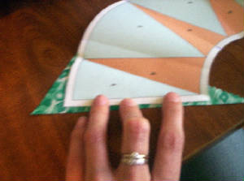](http://quilterscornerclub.tripod.com/imagelib/sitebuilder/misc/show_image.html?linkedwidth=560&linkpath=http://www.quilterscornerclub.com/sitebuildercontent/sitebuilderpictures/.pond/000_1137.jpg.w560h416.jpg&target=tlx_new)

* ***Now, I will leave the paper folded down while I add the piece 2 fabric. I will position the piece 2 fabric FACE UP under the piece 1 fabric, and here I have darkened the piece 2 lines, from the back, to show better here… You will probably be able to see these through your paper… use this as a guide for your next piece (#2) If the fabric covers this entire area plus a ¼ inch seam allowance then you KNOW your fabric will cover it when sewn. See picture below…***

[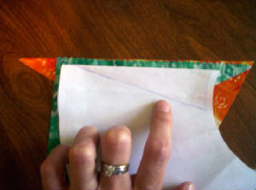](http://quilterscornerclub.tripod.com/imagelib/sitebuilder/misc/show_image.html?linkedwidth=560&linkpath=http://www.quilterscornerclub.com/sitebuildercontent/sitebuilderpictures/.pond/000_1139.jpg.w560h416.jpg&target=tlx_new)

***Remember my Paper is still folded here and I can see that my orange fabric for the # 2 piece will cover the area I darkened, with room for seam allowance…***

* ***Once I have all that positioned, I sew down the first sew line using a VERY short stitch length, to help when removing the paper later***

[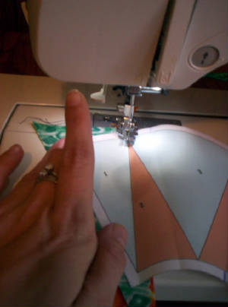](http://quilterscornerclub.tripod.com/imagelib/sitebuilder/misc/show_image.html?linkedwidth=560&linkpath=http://www.quilterscornerclub.com/sitebuildercontent/sitebuilderpictures/.pond/000_1140.jpg.w560h754.jpg&target=tlx_new)

* ***Once sewn I will flip to the front and press the fabric open***
* [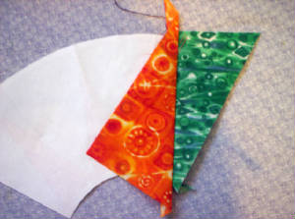](http://quilterscornerclub.tripod.com/imagelib/sitebuilder/misc/show_image.html?linkedwidth=560&linkpath=http://www.quilterscornerclub.com/sitebuildercontent/sitebuilderpictures/.pond/000_1141.jpg.w560h416.jpg&target=tlx_new)
* ***Now I am going to turn the piece over again, see how tiny my stitches are…and FOLD the paper again, this time on the piece 2-3 Sew Line…***

|  |  |
| --- | --- |
| [000_1142.jpg](http://quilterscornerclub.tripod.com/imagelib/sitebuilder/misc/show_image.html?linkedwidth=560&linkpath=http://www.quilterscornerclub.com/sitebuildercontent/sitebuilderpictures/.pond/000_1142.jpg.w560h416.jpg&target=tlx_new) | [000_1144.jpg](http://quilterscornerclub.tripod.com/imagelib/sitebuilder/misc/show_image.html?linkedwidth=560&linkpath=http://www.quilterscornerclub.com/sitebuildercontent/sitebuilderpictures/.pond/000_1144.jpg.w560h416.jpg&target=tlx_new) |

* ***Here you can see my paper is folded down along the piece 2-3 sew line, and I am going to TRIM the excess fabric down to a ¼ inch (or so, it doesn’t have to be perfect when you paper piece, I don’t even bother to measure ☺ oops! did I break another rule!! ☺ )***

[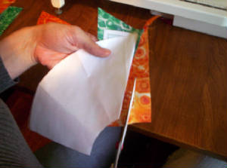](http://quilterscornerclub.tripod.com/imagelib/sitebuilder/misc/show_image.html?linkedwidth=560&linkpath=http://www.quilterscornerclub.com/sitebuildercontent/sitebuilderpictures/.pond/000_1143.jpg.w560h416.jpg&target=tlx_new)

* ***Next, I am going to lay my Piece 3 fabric under the piece 2 fabric along the line I cut on the edge of my seam allowance (piece 3 was rather large so I did not cut on the diagonal, I just cut a rectangle 1 inch wider than the piece all around… and will use the left overs for another block…Once again here I darkened the piece 3-4 sew line on the back side of the paper so you can see that my fabric will cover this entire area with plenty of room for error…***

[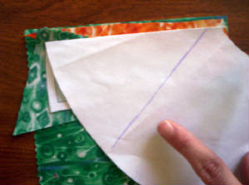](http://quilterscornerclub.tripod.com/imagelib/sitebuilder/misc/show_image.html?linkedwidth=560&linkpath=http://www.quilterscornerclub.com/sitebuildercontent/sitebuilderpictures/.pond/000_1149.jpg.w560h416.jpg&target=tlx_new)

* ***Once your piece 3 fabric is positioned, sew along the 2-3 sew line, press open, fold down the next sew line and trim down the seam allowance. Repeat this for the rest of the pieces of this unit… Here***
* ***is my funky looking unit all pieced*** [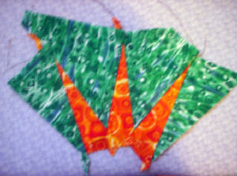](http://quilterscornerclub.tripod.com/imagelib/sitebuilder/misc/show_image.html?linkedwidth=560&linkpath=http://www.quilterscornerclub.com/sitebuildercontent/sitebuilderpictures/.pond/000_1153.jpg.w560h416.jpg&target=tlx_new)
* ***Now trim all around this unit, to your ¼ inch seam allowance edge- (I left a little extra on mine but I don’t really recommend doing it that way, it could confuse you when lining up the units to sew together, its easier to just line up the exactly cut seam allowances… I’m just lazy ☺ )***

[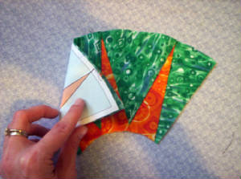](http://quilterscornerclub.tripod.com/imagelib/sitebuilder/misc/show_image.html?linkedwidth=560&linkpath=http://www.quilterscornerclub.com/sitebuildercontent/sitebuilderpictures/.pond/000_1154.jpg.w560h416.jpg&target=tlx_new)

***After I am done trimming this down, I also sew (baste) all the way around this piece inside the seam allowance… I’m telling you, this really helps keep your fabric from flipping back, or moving at all while sewing the Units together, which has happened to me several times, then I was stuck trying to rip out my tiny stitches for an hour, this is my solution to that problem***

* ***Now I am going to get ready to sew my curved units together… First, I’m going to clip down to the edge of where I sewed inside the seam allowance, across both unit A and B… I clip both units, whether or not that’s the “correct way” I don’t know, its just My Way***

|  |  |
| --- | --- |
| [000_1157.jpg](http://quilterscornerclub.tripod.com/imagelib/sitebuilder/misc/show_image.html?linkedwidth=560&linkpath=http://www.quilterscornerclub.com/sitebuildercontent/sitebuilderpictures/.pond/000_1157.jpg.w560h416.jpg&target=tlx_new) | [000_1159.jpg](http://quilterscornerclub.tripod.com/imagelib/sitebuilder/misc/show_image.html?linkedwidth=560&linkpath=http://www.quilterscornerclub.com/sitebuildercontent/sitebuilderpictures/000_1159.jpg&target=tlx_new) |

* ***Ok, here’s where the explaining gets very tricky- Once everything is all clipped, I line the Right edge of my unit A (face down) along the Right edge of my Unit B (face up) as shown below… I insert a pin, making sure it hit’s the corners of my paper templates on both pieces. Then pin in place, keeping the pin fairly high up because I want to have flexibility when pinning the rest of the places.***

[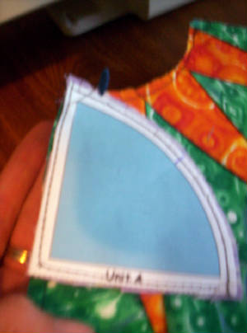](http://quilterscornerclub.tripod.com/imagelib/sitebuilder/misc/show_image.html?linkedwidth=560&linkpath=http://www.quilterscornerclub.com/sitebuildercontent/sitebuilderpictures/.pond/000_1162.jpg.w560h754.jpg&target=tlx_new)

* ***Now I’m going to pull the left side of unit A and line it up with the left side of unit B as shown below ( See how the unit B curves inward, that’s OK its what its supposed to do.. Pin this side in place just as you did the other side…***

[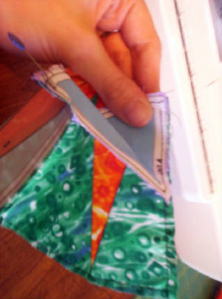](http://quilterscornerclub.tripod.com/imagelib/sitebuilder/misc/show_image.html?linkedwidth=560&linkpath=http://www.quilterscornerclub.com/sitebuildercontent/sitebuilderpictures/.pond/000_1164.jpg.w560h754.jpg&target=tlx_new)

***And once pinned your piece should look like this…***

[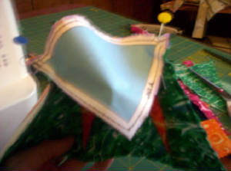](http://quilterscornerclub.tripod.com/imagelib/sitebuilder/misc/show_image.html?linkedwidth=560&linkpath=http://www.quilterscornerclub.com/sitebuildercontent/sitebuilderpictures/.pond/000_1165.jpg.w560h416.jpg&target=tlx_new)

* ***Now pin the same way, where you marked your center lines…***

[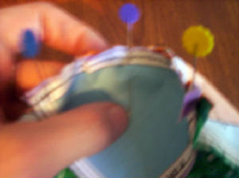](http://quilterscornerclub.tripod.com/imagelib/sitebuilder/misc/show_image.html?linkedwidth=560&linkpath=http://www.quilterscornerclub.com/sitebuildercontent/sitebuilderpictures/.pond/000_1166.jpg.w560h416.jpg&target=tlx_new)

* ***and then in-between the center and edge on each side, so your pinned units should look like this:***

[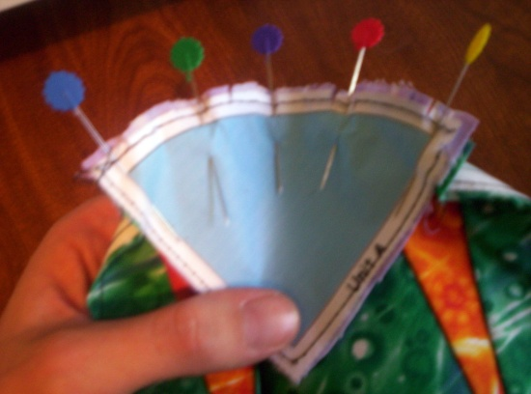](http://quilterscornerclub.tripod.com/imagelib/sitebuilder/misc/show_image.html?linkedwidth=560&linkpath=http://www.quilterscornerclub.com/sitebuildercontent/sitebuilderpictures/000_1167.jpg&target=tlx_new)

***As you do all of the pinning, manipulate the fabric and paper to lay flat.***

* ***Now just follow the line of your seam allowance and sew (slowly), manipulating the units so they stay flat, and nothing is getting up under the sewing area- I like to use a slightly larger stitch for this part than I use for the regular paper piecing…***

[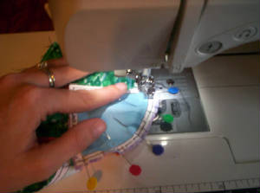](http://quilterscornerclub.tripod.com/imagelib/sitebuilder/misc/show_image.html?linkedwidth=560&linkpath=http://www.quilterscornerclub.com/sitebuildercontent/sitebuilderpictures/.pond/000_1168.jpg.w560h416.jpg&target=tlx_new)

***And here is my unit A/B sewn together and pressed open (paper and all)***

[](http://quilterscornerclub.tripod.com/imagelib/sitebuilder/misc/show_image.html?linkedwidth=560&linkpath=http://www.quilterscornerclub.com/sitebuildercontent/sitebuilderpictures/.pond/000_1169.jpg.w560h416.jpg&target=tlx_new)

* ***I’m going to do the same thing now, pinning on the Unit C (face down) onto the Pieced A/B unit - Lining up the Right edges, pinning down, then the left edges, then the center and inbetween the center and the edges on both sides…as shown***

[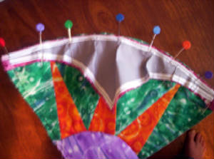](http://quilterscornerclub.tripod.com/imagelib/sitebuilder/misc/show_image.html?linkedwidth=560&linkpath=http://www.quilterscornerclub.com/sitebuildercontent/sitebuilderpictures/.pond/000_1172.jpg.w560h416.jpg&target=tlx_new)

* ***Now sew along your seam allowance line again- using a larger stitch (but not so large the paper will not come off) I think I used about 2.5 stitch length for this.. (And a 1.6 for my paper piecing)… And I press this open here is the front- It needs to be trimmed down to the seam allowance paper edge-***

[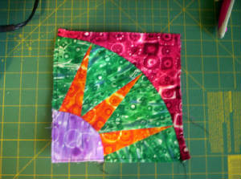](http://quilterscornerclub.tripod.com/imagelib/sitebuilder/misc/show_image.html?linkedwidth=560&linkpath=http://www.quilterscornerclub.com/sitebuildercontent/sitebuilderpictures/.pond/000_1173.jpg.w560h416.jpg&target=tlx_new)

***Which I do here- Back side- Trimmed***

[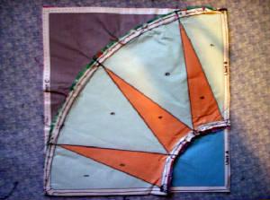](http://quilterscornerclub.tripod.com/imagelib/sitebuilder/misc/show_image.html?linkedwidth=560&linkpath=http://www.quilterscornerclub.com/sitebuildercontent/sitebuilderpictures/.pond/000_1174.jpg.w560h416.jpg&target=tlx_new)

***Yes my paper gets all crinkly while I am manipulating the block and sewing- But here is the finished result- a pretty perfect 7 ½ inches all the way around-***

[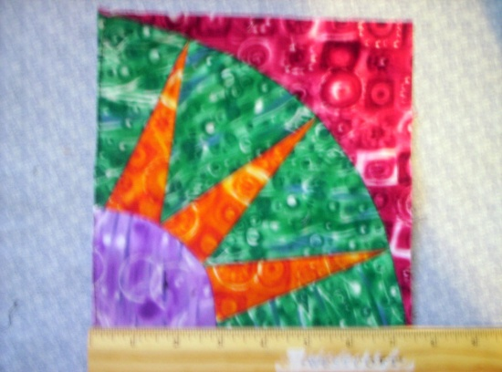](http://quilterscornerclub.tripod.com/imagelib/sitebuilder/misc/show_image.html?linkedwidth=560&linkpath=http://www.quilterscornerclub.com/sitebuildercontent/sitebuilderpictures/000_1176.jpg&target=tlx_new)

***And that’s how I make a New York Beauty block, I hope you will find this information helpful in some way***